**LAB # 12 Assignment**

**Roll no: 20k-0409 Name: Mukand**

Ques 1:

**Implement JK flip- flop by using logic gates.**

|  |  |  |  |
| --- | --- | --- | --- |
| Input 1 | Input 2 | Input 13 | Output 12 |
| 0 | 0 | 0 | 1 |
| 0 | 0 | 1 | 1 |
| 0 | 1 | 0 | 1 |
| 0 | 1 | 1 | 1 |
| 1 | 0 | 0 | 1 |
| 1 | 0 | 1 | 1 |
| 1 | 1 | 0 | 1 |
| 1 | 1 | 1 | 0 |

|  |  |  |
| --- | --- | --- |
| Input 1 | Input 2 | Output 3 |
| 0 | 0 | 1 |
| 0 | 1 | 1 |
| 1 | 0 | 1 |
| 1 | 1 | 0 |

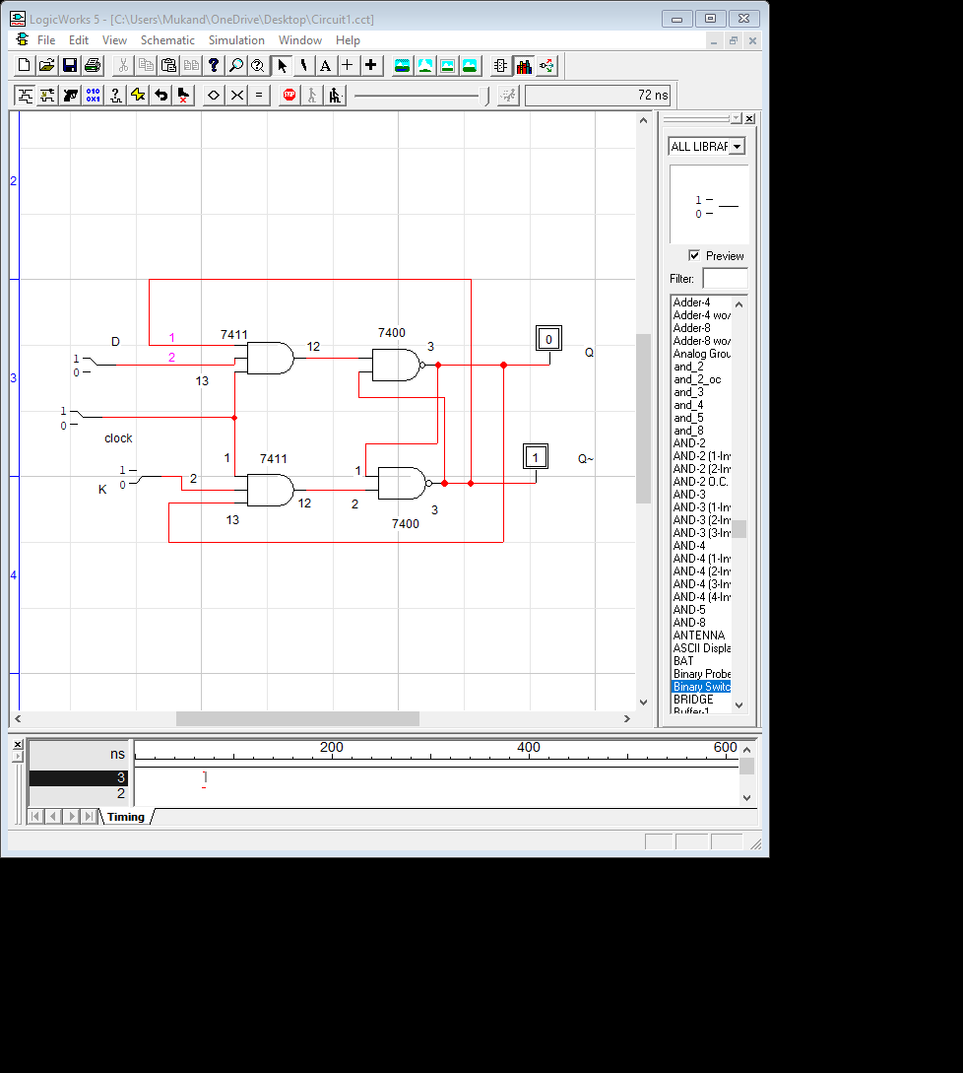

Ques 2:

**Implement D Latch by using logic gates.**

ANS:

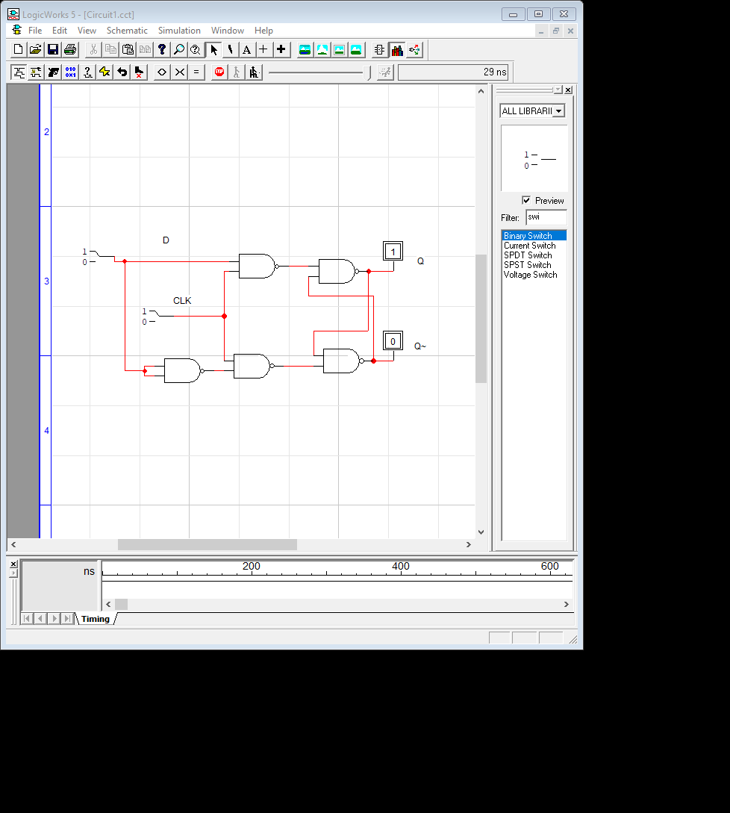

|  |  |  |  |
| --- | --- | --- | --- |
| E | Clock | Q | Q~ |
| 0 | 0 | latch | Latch |
| 0 | 1 | latch | Latch |
| 1 | 0 | 0 | 1 |
| 1 | 1 | 1 | 0 |